|  |
| --- |
| General instructions for preparation of papers for TC207 International Seminars “Soil-Structure Interaction. Underground Structures and Retaining walls”  Author 1 & Author 2  Affiliation, Country  Author 3  Affiliation, Country |
| **Abstract**: Authors should follow these guidelines to prepare their papers for the International Seminars “Soil-Structure Interaction. Underground Structures and Retaining walls” on October 3, 2016 in Vienna, Austria. Please type your paper into this template. Remember that your article must be print-ready without any major pre-press corrections.  In this section please type the abstract of 100-120 words. Please do not change the size of this section even if your abstract is comparatively short.  **Keywords.** keyword, keyword, keyword |

1. HEADING: GENERAL REQUIREMENTS

Dear authors, please follow the rules outlined below to facilitate publication of the Conference Proceedings.

Format of the files: Microsoft Word and Adobe PDF (both are required).

Size of hard copy of Proceedings: 175×245 mm.

Authors should limit the size of their papers to 8 pages of A4 size (number of pages must be even in order to avoid blank pages). Margins must be given from this template. For the main text use Times New Roman 10 point size font with 11 point line spacing (style “Body Text”). Do not use any other font. For figure captions, references please use 9 point size font (styles “Figure caption”, “Reference text”). For tables use 8 point size font (style “Table Text”). To provide uniformity of style please avoid using bold and italics and never underline any text. Never change the size of the abstract or author sections.

Always create headings, subheadings, main text, tables, figure captions and references with the appropriate styles.

* 1. Subheading: equations

For equations please use the Microsoft Equation Editor. Equations should be placed to the left of the column with no indentation. Equation numbers should be placed in parenthesis at the end of the line to the right of the column.

To refer to equations in the main text, use the following style: Equation (1) or (Eq. 1).

For example:

, (1)

where η0  and η are the initial and final values of coefficient of viscosity, respectively, *a* – acceleration of soil vibrations; *g* – acceleration of gravity.

**Please do not use Equations editor for inline equations in the text.** Use subscript and superscript options for them, for example *B*= (*C*+ *D*)*n*.

* 1. Figures and photographs

All the figures and photographs should be pasted into the paper (not linked!). All graphs, pictures and photographs can be in colour and black&white or grayscale and of good contrast. Avoid using thin lines in graphs, as thin lines may not come out well in print. The graphs with grey lines or symbols will not be accepted for publication for same reason.

The Publisher will accept figures and photographs only in electronic format.

Photocopies from books or journals, as well as photocopies of photographs and screened photographs will not be accepted.

Place figure captions with the given style right below the figure. Leave one line of space between the figure caption and the text.



**Figure 1**. Mean annual water level of the Baltic Sea.

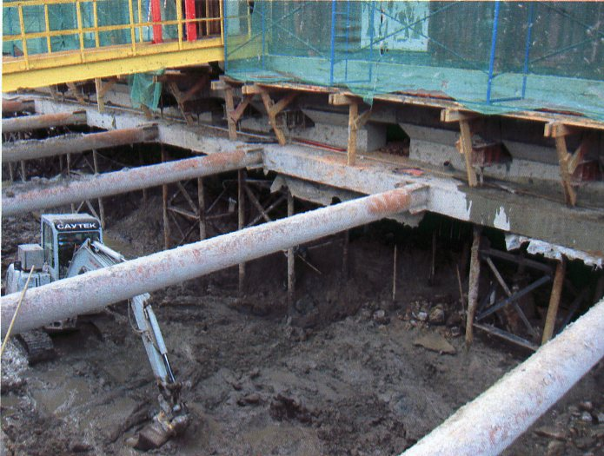

**Figure 2**. Photographs should be grayscale or black and white.

* 1. Tables

For creating tables use the pattern shown below.

**Table 1**. Parameters of the non-linear model

|  |  |  |  |  |
| --- | --- | --- | --- | --- |
| **Type of Soil** | **E, MPa** | **ν** | **c, kPa** | **φ, deg** |
| Stiff clay | 30 | 0.4 | 25 | 15 |
| Sand | 25 | 0.3 | 2 | 29 |
| Loam | 10 | 0.35 | 15 | 20 |

Leave one line of space between the table or the figure caption and the following text.

1. REFERENCES

Last name, Initials, (ed.) year. *Book title*. City: Publisher.

Last name, Initials year. Title of article. *Title of Journal*, volume number, issue number, page numbers.

Use the above format for references. Put references at the end of your paper in alphabetical order. If you mention several works of the same author arrange them consecutively in chronological order.

Examples:

Barden, L. 1970. Consolidation of clay with linear viscosity. *Geotechnique,* Vol. 15, No. 4, pp. 345-362.

Yin, I.-H. & Graham, I. 1999. Elastic viscoplastic modeling of the time-dependent stress-strain behaviour of soils. *Can. Geotech. Journal*, Vol. 31, No. 1, pp. 42-52.

1. paper submission

Please send your paper typed in this template by e-mail to:

[lisyuk@gmail.com](mailto:lisyuk@gmail.com)

and

[georec.spb@gmail.com](mailto:georec.spb@gmail.com)

Total size of all or the files sent should not exceed 20 Mb. If the file size is greater, please send multiple messages or the link to uploaded file on the upload site.

In case of any problem address to the Organizing Committee at e-mails above.

**Important deadlines:**

Paper submission — 10 December 2016.

Notification of acceptance — 25 December 2016.

Seminars:

3 October 2016 – Vienna, Austria (completed).